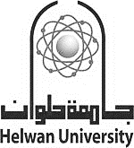

**Helwan University**

**Faculty of Computing and Artificial Intelligence**

**Information Systems Department**

Exercise and diet by AI

A graduation project dissertation by:

Omar Zakaria Mohy ALdeen 20210603

Seif Eldin Ahmed Mohamed 20210434

Ali Ahmed Abdelmawgoud 20210573

Omar Khaled Abdo Hussien 20210599

Ziad Mohamed Abdallah Hassan 20210374

Shehab Tamer Salama 20210458

Submitted in partial fulfilment of the requirements for the degree of Bachelor of Science in Computing & Artificial Intelligence at the **Information Systems** Department, the Faculty of Computing & Artificial Intelligence, Helwan University

Supervised by:

Dr. Mostafa Adel

June 2025